

Year 4 CCTV Academic Year 2020-2021
Queen’s University Belfast

Name of GP Practice:

Name of GP Tutor:

Academic Year: 2020-2021

Dear CCTV GP Tutor,
On behalf of myself, and the rest of the QUB General Practice Team, we would like to extend our thanks to you all for your continued efforts during these very difficult times. While we appreciate your support every year, we particularly welcome it for the academic year 20/21 amidst the pandemic turbulence which has transformed so many aspects of our lives, both professionally and personally.
We know that since the beginning of this pandemic you have been working tirelessly to
maintain services for your patients and we acknowledge that things may become even more
difficult during the coming months and into early next year.
As a new academic year begins we appreciate that there will be challenges to face, however,
we want to ensure that our students continue to enjoy and develop their consultation skills
through the CCTV experience and for you to balance time devoted to this with your clinical
commitments. We have been developing innovative ideas and will be running an adapted
CCTV educational platform for this year which this guide will outline.

CCTV Lead

Dr Carla Devlin
Clinical Teaching Fellow
What is CCTV (Closed Circuit Television)?
CCTV has long roots in Queen’s University Belfast, dating back to the 1980s. It has been a highly rated experience for our medical students to date. Active patient involvement allows students to develop and enhance effective consulting skills, interviewing skills and clinical reasoning skills. This rich learning opportunity allows students to appreciate and understand the principles of chronic disease management in the community setting. The student also gets to consider how the patient should be managed e.g. health promotion, investigations and the writing of prescriptions. They only need to apply the basic history taking skills and primary interview model, but these activated consultations are supported by Clinical Tutors in real live time with instant 1:1 feedback.
Scope of CCTV
Before the Covid-19 pandemic began, students were allocated in groups of 2-3 to General Practitioners in the Greater Belfast Area which had the legacy physical equipment installed. Due to advances and opportunities that technology bring, this has now been extended to include all GP Tutors across NI.
How will CCTV work this year?
As you are aware, the previous equipment used for Year 4 CCTV teaching had become dated and, at times, difficult to maintain, repair and replace (below left photo). The equipment is now obsolete. The Centre for Medical Education (CME) has been investigating alternative methods for the delivery of CCTV teaching. Due to COVID-19, online teaching has been successfully introduced across many specialties through a range of platforms.
Therefore, in Academic Year 2020-21, CME are planning for delivery of CCTV teaching via the online platform Zoom (see below right photo). We would like to retain elements of the traditional CCTV teaching model and we realise that this year it is not going to be perfect as there are so many constraints on all of us but we hope to do the best that we can under the current circumstances.
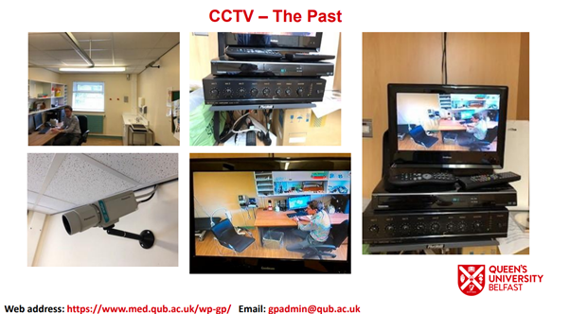 | 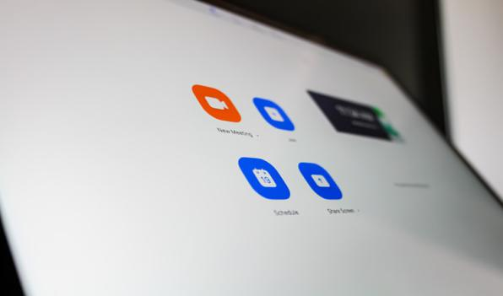
CCTV – The Past | CCTV – The Future

Practice Zoom Licence & Headset/Webcam
Zoom Pro Account Licence set up
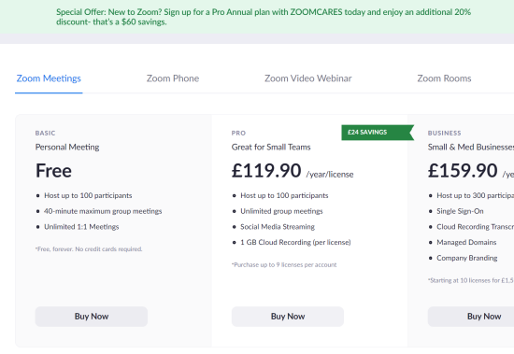
- Go to https://zoom.us website
- Go to plans and pricing
- Go Zoom Pro Account and press buy now
- Add 1 host and click annual which will be £119.90+vat (£143.88) billed annually
- This is reclaimable from SUMDE. We will send a link to claim for this expenditure in due course.

Purchasing a Headset/Webcam
- Purchase a web and speakers
- An award of £45 per eligible practice is available to support the purchase of a suitable webcam/speaker
- This is reclaimable from SUMDE via a link to claim in due course.
Email from the SUMDE office to Practices with Legacy CCTV Equipment
Please note that the current contract for installation and maintenance will cease from 1st October as Zoom or AccuRx is implemented. Some practices have indicated a wish to keep the CCTV equipment for their own use. Practices wishing to do so, will be required to confirm full and complete ownership of the equipment from 1st October 2020 (see Appendix 1). SUMDE funding will not be available after this date for any aspect of maintenance, repair or for removal of the equipment or associated electrical/building work after this time. Alternatively, SUMDE Office will arrange for uplift of the equipment.
Please contact SUMDE Office for further information.
Susie Hart| SUMDE Office| Ground Floor| Whitla Medical Building|97 Lisburn Road| Belfast| BT9 7B| Tel. 028 9097 2433|
Email: sumde@qub.ac.uk

Patient Selection
Patients are informed ahead of their appointment time and advised that they will be consulting with a senior medical student. We would be keen to maintain the traditional element of the CCTV experience which involves patients presenting to the GP practice with an acute problem (having not been triaged by the GP). The patients can have a wide range of presenting complaints/symptoms. The appropriateness of patient selection is left to the discretion of the Clinical Tutor as you know your patients’ the best. Your patient can be given the choice to consult with the student via a telephone triage or video consultation. Please inform the patient that this will be recorded and then viewed for the purposes of the educational session and then deleted.

Patient connection – Telephone or Zoom?
You can have the student conduct the consultation by telephone (see an explanation of how you do this via our CCTV explanatory video – separate link sent) or if you have a patient who would be happy to do so you could also send them the Zoom link. It is up to you.

Patient Consent

- If you wish to have written consent before the consultation, we have provided you with an up to date consent form for video and telephone consultations (see Appendix 2).
- Communication and return of the consent form is the responsibility of the practice.
- However, in the current circumstances verbal consent, noted in the Patient’s notes is adequate

Creating a zoom session and preparation prior to the teaching session
- Use of preparation time
  - Check eGPlearning You tube
  - General information on Video consulting to share with students:
https://bjgplife.com/wp-content/uploads/2020/03/Video-consultations-a-guide-for-practice.pdf
- Create a zoom meeting – see appendix 3
- When creating a Zoom Call ensure that you allocate a waiting room to the call. This will enable control if inviting patients in to a video call.
- GP Tutor or Practice Manager to email each student with the Zoom Code in preparation of the session – see appendix 3
- If using video for your patient contact each Patient with the Zoom Code in preparation of the session (you will need the patients email address or mobile number)

On the day of the CCTV Session
Press the start button for the session that you have created

If you log into your account via the Zoom.us website it will look like this:
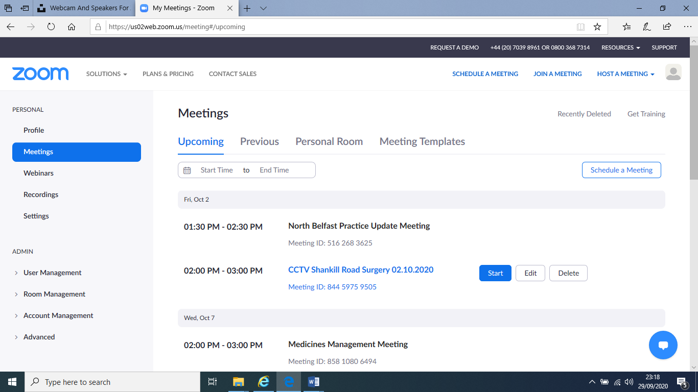

If you are logging in via the Zoom App (which you can download) it will look like this:
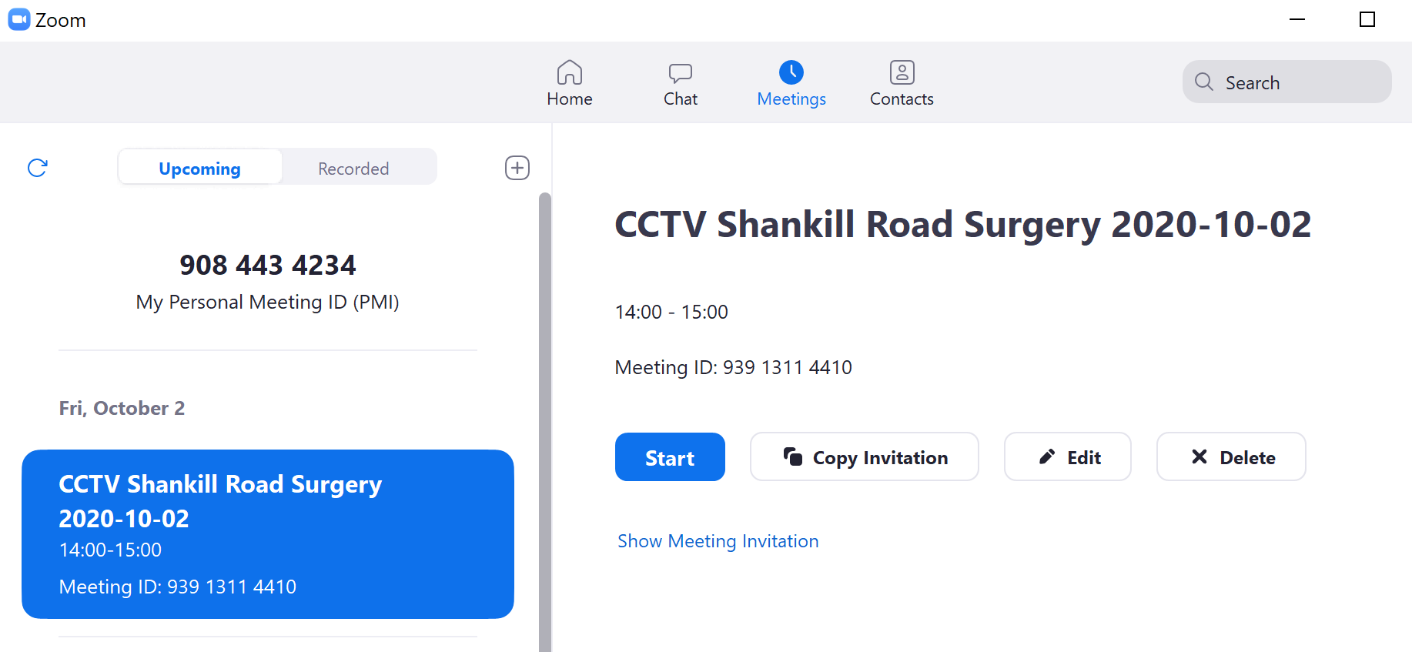
Enter your full name (or check that the name hasn’t changed if you use a PC in the practice) to allow others to identify you during the meeting. At the bottom of the video screen is a menu bar (if you can’t see it, move your mouse down towards the bottom of the screen)

Glossary of functions from left to right:

Microphone icon: Click to mute or unmute microphone
Audio drop down arrow: Check audio settings
Video icon: Stop or enable video
Video drop down arrow: Check video settings
Invite: Invite others to the ECHO meeting
Participants: See who else is in the meeting
Share Screen: Share a document/presentation so that it can be seen by others
Chat: Send a chat message to other participants.
This can be a group message or a private message
Record: Used to record within the zoom session
NB Choose Record to Computer
- When you press stop recording that will be one video downloaded to your computer on ending the meeting.
- If you start to record a second consultation during the Zoom meeting and then stop it, at the ending of the meeting you will find two videos downloaded
- Zoom defaults to store the video in a folder named with the date and time of the session. This folder is found in Documents/Zoom
- On leaving the meeting zoom will inform you that the recording is being saved to the Computer.

Example Timetable of the CCTV Session

Suggested Timetable

2:00pm Welcome and Introduction

2:20pm Consultation 1 with Student 1

2:40pm Consultation 2 with Student 2

3:00pm Coffee Break

3:10pm Reflection and Feedback including 1:1 feedback for each student

3:45pm Closing remarks

An example of Welcoming Slide which can be on the screen as the students are admitted into the zoom call

(Save the slide onto the desktop of the computer and press share screen)

Name of the practice X

Dr X…..Welcomes you to your CCTV Session

Timetable for your CCTV Session

2:00pm Welcome and Introduction

2:20pm Consultation 1 with Student 1

2:40pm Consultation 2 with Student 2

3:00pm Coffee Break

3:15pm Reflection and Feedback

3.45pm Closing Remarks

Welcome and Introduction
This is a really important part of the CCTV session as it sets the tone for the rest of the afternoon. It is worthwhile letting the rest of the Practice Team know that you will be doing the CCTV session to avoid any unnecessary interruptions.
- Brief chat with each student in turn – also serves as a sound check
It can include the following
- Learning outcomes for the CCTV session
- Etiquette reminders
  - Ask students to mute their microphones when not in use to improve audio
  - Advise the students that the consultations will be recorded
  - Reminder about patient confidentiality
- Encourage the students to use the chat function

Each Consultation (Video Consultation or Telephone Triage Consultation)
- N.B. Instructions to the Student
  - They should be in Private Place
  - Their Video should be turned on
  - They should be in a place where they cannot be overheard or seen by anyone else
  - They should ideally wear headphones with a mike

- Video or Telephone Consultation
  - CCTV Clinical Tutor should do the following:
    - Informs the patient that they are going to be asked to initially speak with a student
    - Inform the patient that the session will be recorded
    - That the recording will be used for review in the afternoon only
    - That the recording will be deleted after the session is completed
  - If the patient is happy with all of this the CCTV Clinical Tutor asks the patient for verbal consent
  - All participants on the call including the Clinical Tutor should turn off the video (except the selected student and the patient (if they are joining by video))
  - CCTV Tutor to start recording – CHOOSE RECORD ON THIS COMPUTER

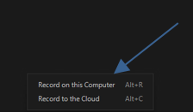
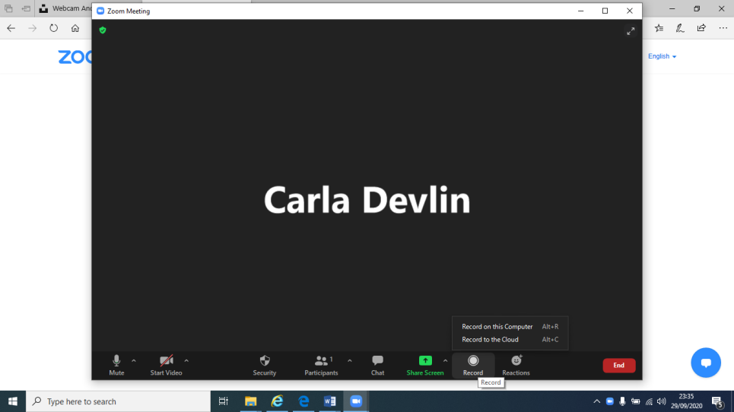

  - The student proceeds with the virtual consultation. The student generally has 10-15 minutes to take a relevant history.
  - Keep an eye on timing approx. 10-15 minutes consultation
  - When the student has naturally completed the consultation or when the 10-15 minutes is up then
  - CCTV Tutor stops the recording
  - CCTV GP tutor turns on video and concludes the consultation with the patient.
  - Thank the patient and student and allow the patient to leave
  - Proceed with the next student and patient consultation
  - Please ensure you record the consultation in the same way
  - Please note for telephone triage consultation
    - Bring the practice phone over to the speakers
    - Put on loud speaker and ensure the student can hear

Obtaining the zoom recordings

We recommend that you let the students have break so that you can obtain the zoom recordings:

- End the meeting for all (this allows the Recorded consultations to be downloaded to your computer)
- Zoom will automatically convert the meeting into a recording

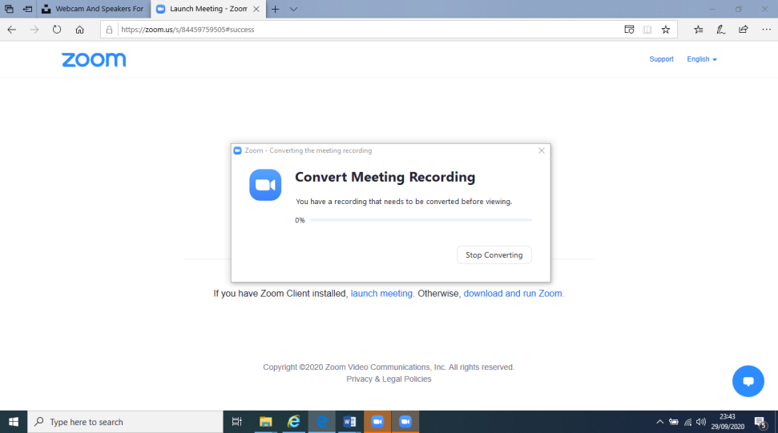

- Save the recordings into documents or desktop

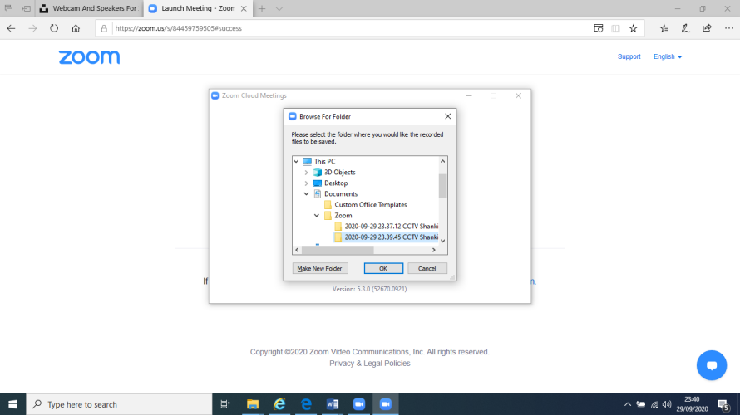

- Open up documents or desktop and you should see the folder named zoom

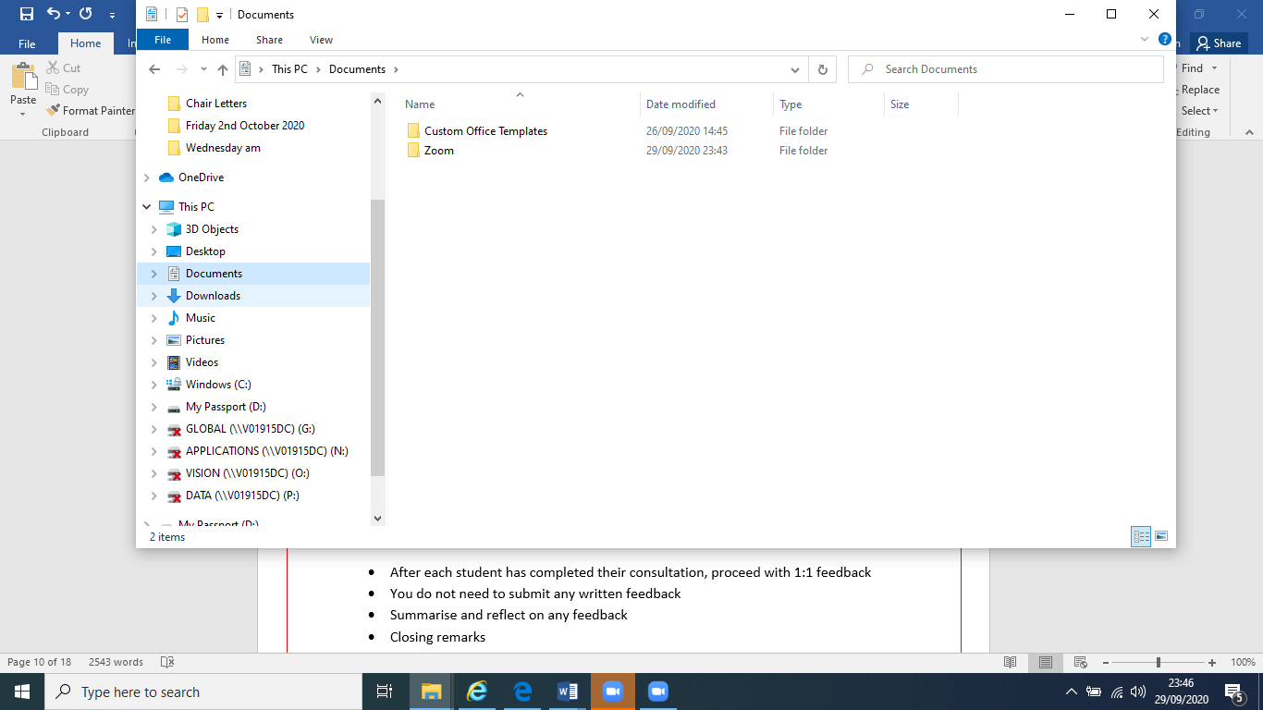
- Double click on the consultation that you would like to comment feedback on

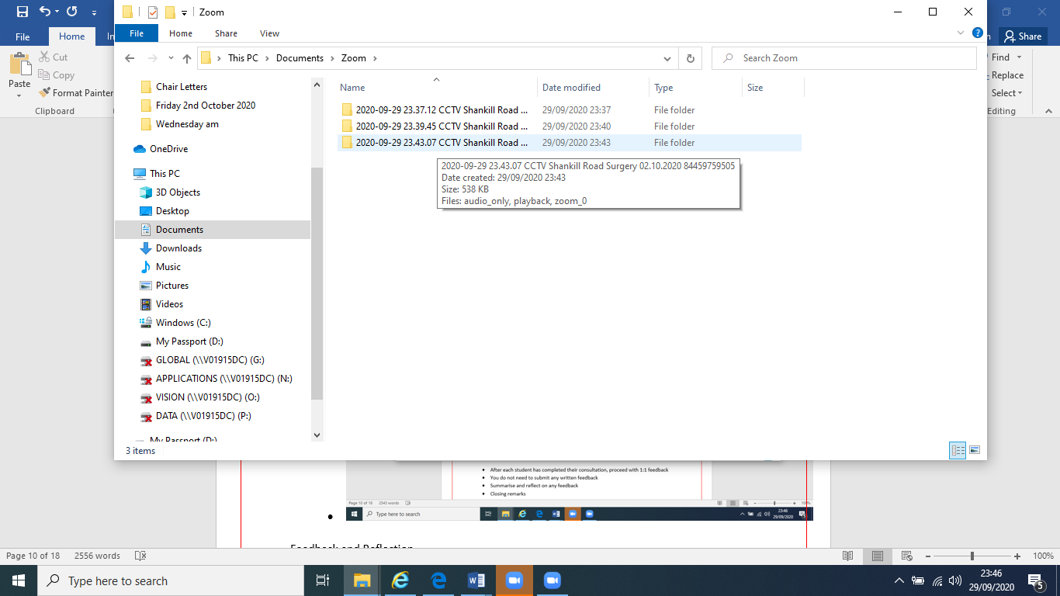

- Double click on zoom file

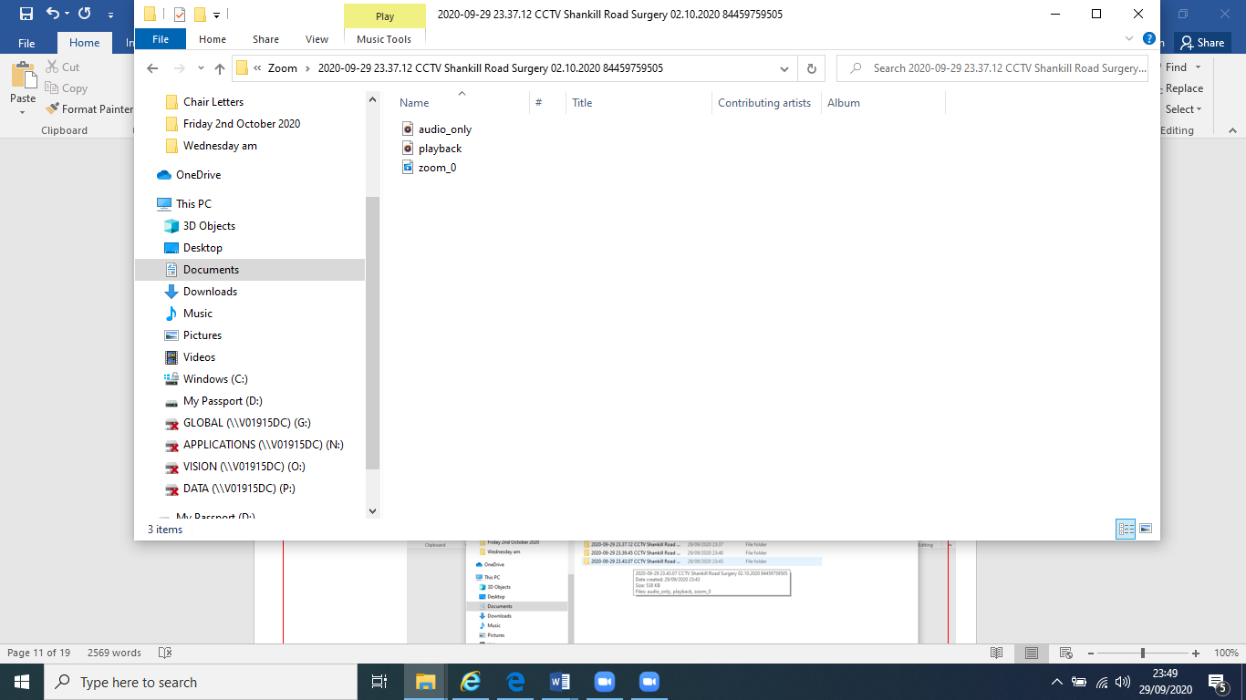

- Press pause on the playing of the video and minimise the screen
- Rejoin the same Zoom meeting and re invite the students back into the session

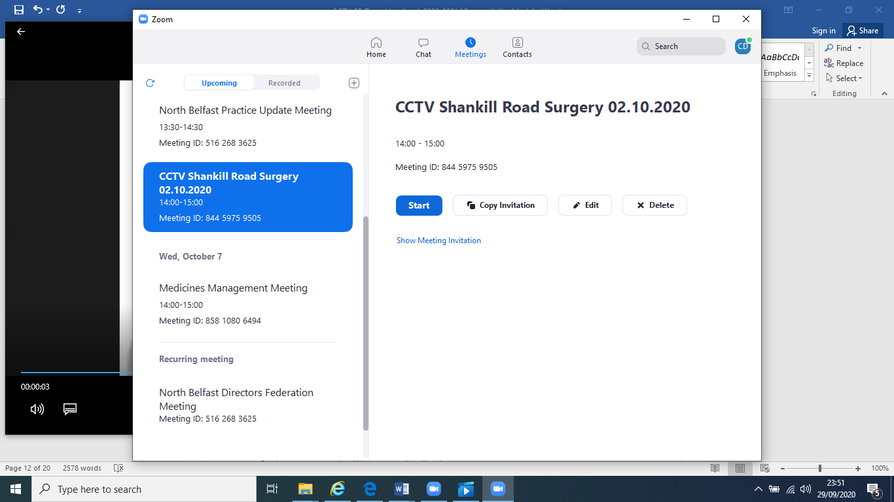

- When the students arrive back into the session and you are ready to show the consultations, then click the Share Screen icon
- Please ensure the two boxes on the bottom left of the screen are ticked
  - Share computer sound
  - Optimise screen sharing for video clip
- Double click the consultation and press share

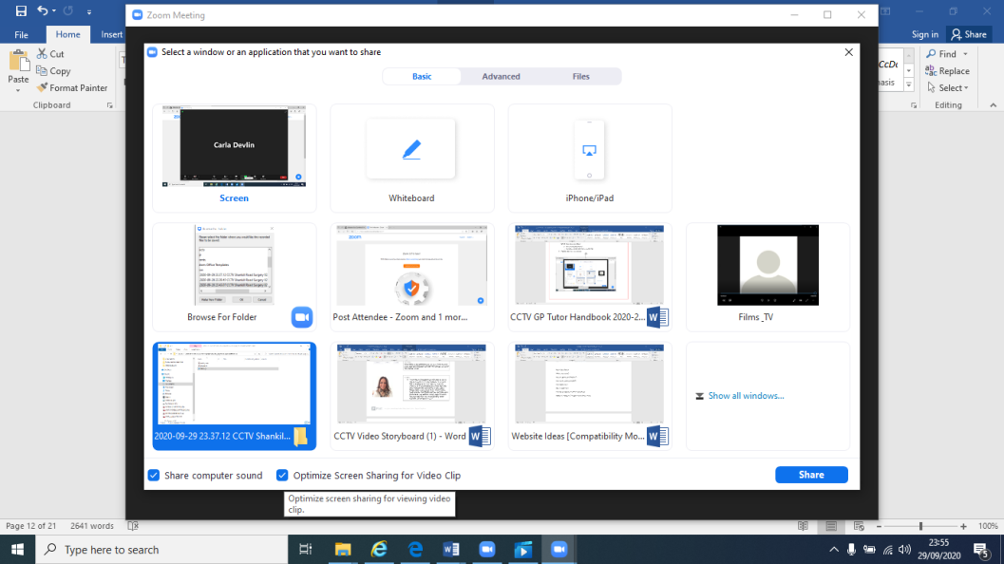

- To stop sharing press Stop Share

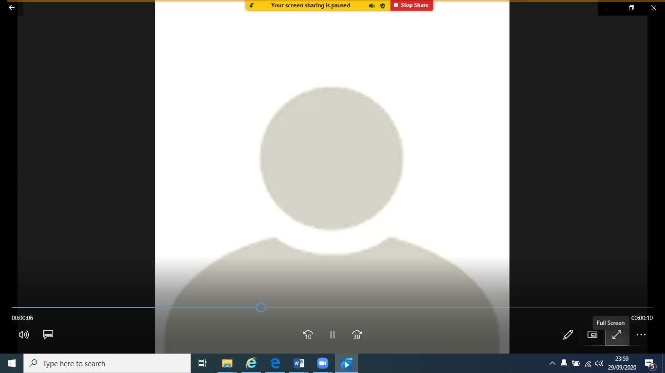

Feedback and Reflection

- After each student has completed their consultation, proceed with 1:1 feedback
- Highlight the positive aspects of the student consultation
- You do not need to submit any written feedback

Closing remarks
- Summarise the learning outcomes achieved
- Summarise the reflection feedback
- Encourage the student to develop
- End of session



TOP TIPS FOR CCTV GP TUTORS

- Prepare for the session and email the students prior to the session
- Ensure that Patients are aware that they are taking part in a CCTV session
- Ensure that you add waiting room to the zoom session
- Open the zoom call 15 minutes prior to the session
- Be prepared
- Know and use the student names, they really appreciate this
- It can be difficult but try to make eye contact with the camera when speaking.
- Allow time to welcome everyone. Early interaction with ALL students encourages ongoing interaction from everyone throughout the session and helps set an expectation for their contribution. Encourage interactions every 5-10mins to maintain attention and engagement.
- Ensure you and the students take a break
- Positive feedback
- Encourage the other student to give feedback on the consultation that they are not participating in
- Ask for feedback from the students about how you can improve the session.



How to contact us

CCTV Admin:
Mrs Eveline Burns/GP admin team
Centre for Medical Education
Whitla Medical Building
Queen’s University Belfast
97 Lisburn Road
Belfast
BT9 7BL
028 9097 2208
gpadmin@qub.ac.uk

QUBGP Web Address
For updated information and useful resources
https://www.med.qub.ac.uk/wp-gp/

CCTV GP Lead:
Dr Carla Devlin
Centre for Medical Education | Queens University Belfast
Whitla Medical Building | Lisburn Road | Belfast | BT9 7BL
https://www.med.qub.ac.uk/wp-gp/

Appendix 1: For those Practices with legacy CCTV equipment

Intention for Practice-based CCTV Equipment
under SUMDE-funded contract
Name of CCTV GP Tutor:
Practice Name:
Practice Address:

Please sign and date one of the two options below as appropriate.
The SUMDE-funded CCTV contract to maintain equipment for Year 4 CCTV teaching will cease from 1st October 2020.
I can confirm that, the above GP Practice wishes:
OPTION A
To accept full and complete ownership and all subsequent maintenance of the equipment with immediate effect.

CCTV Tutor / Practice Manager Signature

Date
OR
OPTION B
SUMDE Office to arrange removal and disposal of the equipment. (Please advise any relevant notes information with regards to uplift/disposal).

CCTV Tutor / Practice Manager Signature

Date

If we have not heard from you by 1st October 2020, we will assume you wish to accept full and complete ownership of the equipment.
Please return to sumde@qub.ac.uk by 30 September 2020.
Appendix 2

Queen’s University Belfast

Patient Written Consent to Video / Audio Recording for

Undergraduate Medical Teaching

Date of video consultation …………………….

GP Lead of video consultation………………………………………

Patient’s name …………………………………… Patient’s H&C…………………………………………….

- Dr ………………………………. would like to perform a video/telephone (delete) consultation with you and a 4th year undergraduate medical student. The purpose of this learning opportunity is to enable students to improve their communication and clinical skills. This video consultation will be seen by another medical student who will be taking part in the teaching session and will be interviewing other patients with the teaching session. This video/telephone consultation will be recorded only for the purposes of the educational session. All consultations will be deleted at the end of the teaching session.
- The video consultation is ONLY of you and the doctor or medical student talking together. The camera will be switched off at any time if you wish. All video recordings are carried out according to guidelines issued by the General Medical Council.
- If you have any further questions please speak to Dr……………………..
- Please sign and return this form to the practice for good record keeping.

To be completed by the Patient

I have read and understood the above information and give my permission to a video consultation.

………………………………………. Date ………………
Signature of the patient

To be filed in the Patient’s Notes

Appendix 3
How to create a CCTV Zoom Meeting

Once you have a Zoom licence, you will be able to create a session for your students. Simply copy the Zoom link and reply all to the email detailing which students are assigned to you

Step 1: Go to www.zoom.us If you download the Zoom App onto your computer you may find this a little easier.

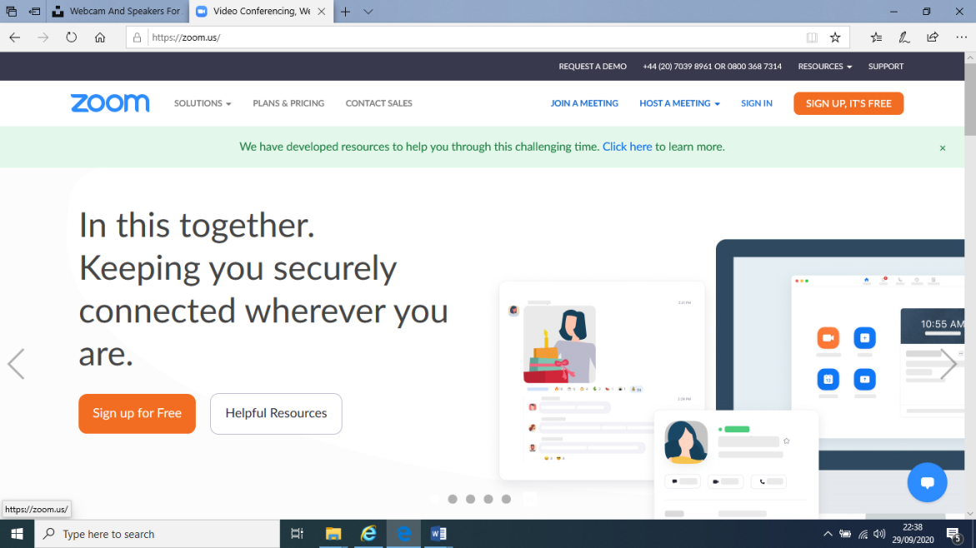

Step 2: Go to sign in page. Use your email address and password allocated to your zoom licence.

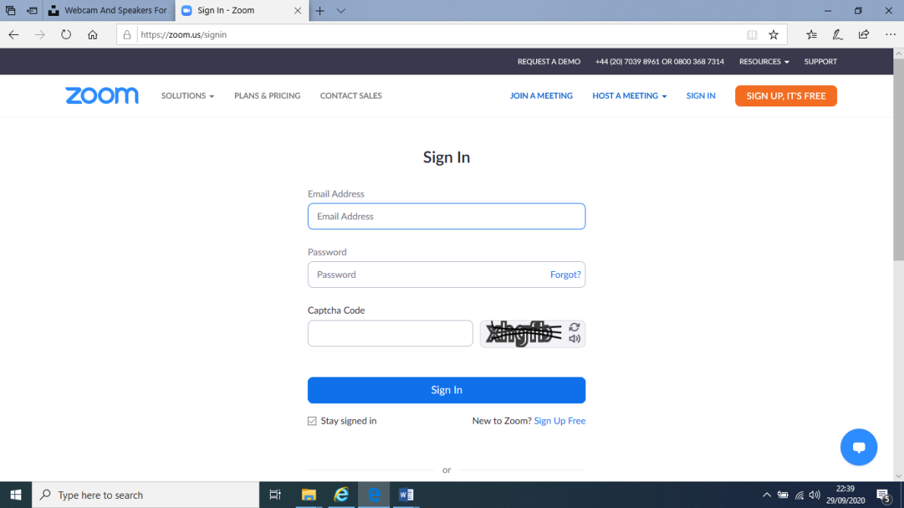

Step 3: Go to “Schedule a Meeting”

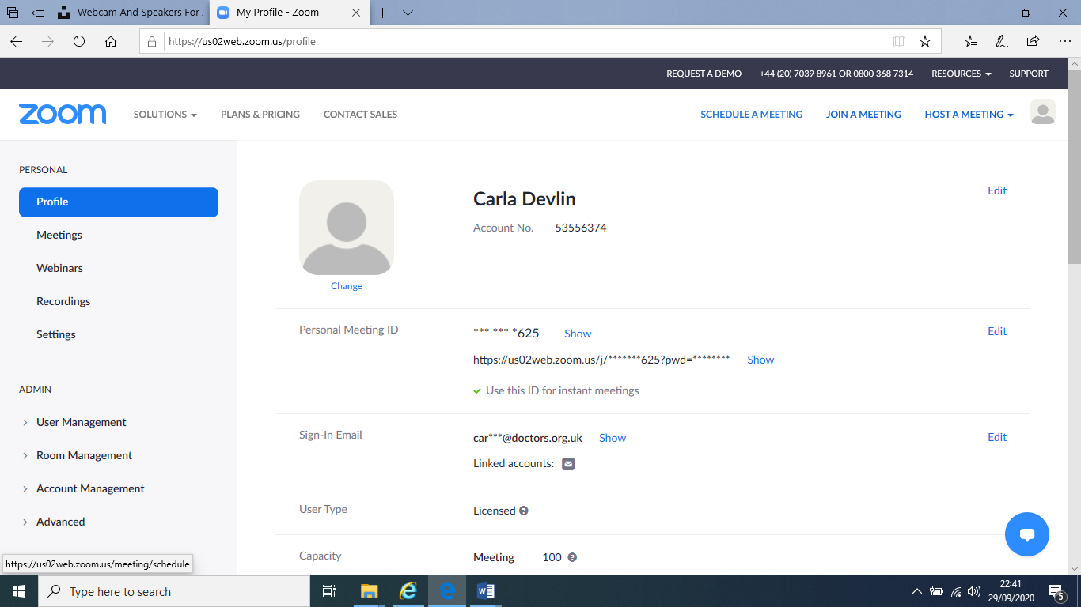

Step 4: Please name your session CCTV, Your Practice Name or Code and the Year Month and Day
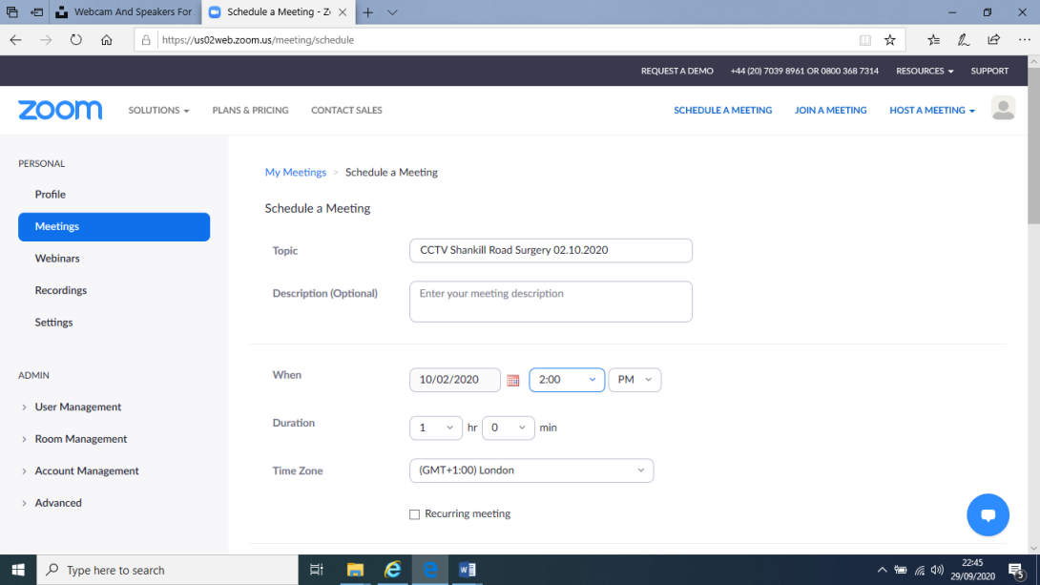

Or use the Zoom App

Please ensure that your zoom session has a waiting room. Admit the students and the patients at specific times during the afternoon session.

Save the session that you have created

Step 5: Copy the invitation and send to the students from your email address (CME Staff will have sent the student email addresses to you prior to the session)

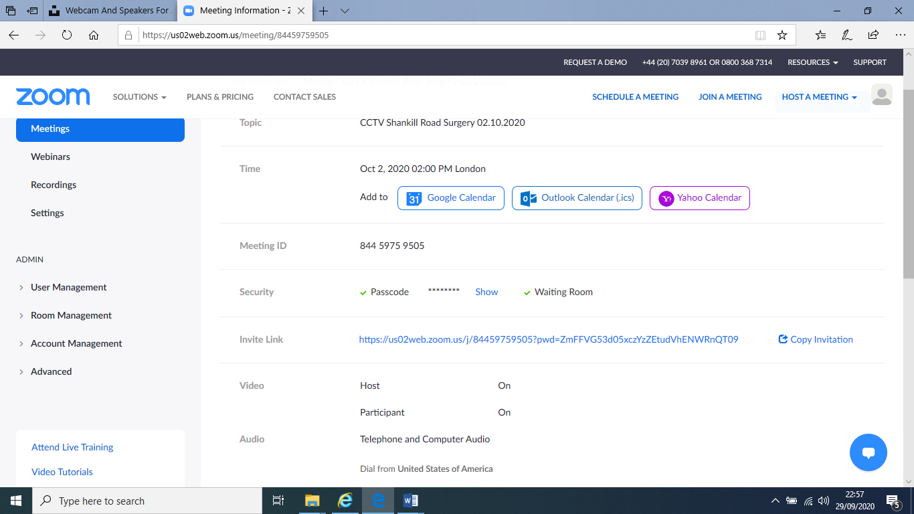

Dr X is inviting you to a scheduled Zoom meeting.

Topic: CCTV Surgery X Date
Time: DATE 02:00 PM London

Join Zoom Meeting
https://us02web.zoom.us/j/8xxxxxxxxxxxxxxxxxxxxxxxxxxxxxxxxxxxxxxxxxxxxxxxxxxxxx

Meeting ID: xxxxxxxxxxx
Passcode: xxxxx
One tap mobile
+19292056099,,84459759505#,,,,,,0#,,706129# US (New York)
+12532158782,,84459759505#,,,,,,0#,,706129# US (Tacoma)

Dial by your location
+1 929 205 6099 US (New York)
+1 253 215 8782 US (Tacoma)
+1 301 715 8592 US (Germantown)
+1 312 626 6799 US (Chicago)
+1 346 248 7799 US (Houston)
+1 669 900 6833 US (San Jose)
Meeting ID: xxxxxxxxxxx
Passcode: xxxxx
Find your local number: https://us02web.zoom.us/u/kevxxxxxxx

